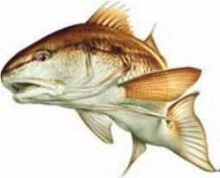
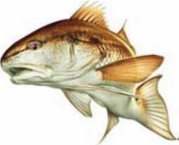
Bay Harbor Fishing Rodeo
JUNE 7th & 8th, 2019

Starts: 8:00 PM Friday June 7th
Ends: 1:30 PM Saturday June 8th
Registration will take place Friday at the Pavilion near the boat basin 6pm-8pm
or you can contact Tim Kurtin by phone (713)254-8166 or fishbaffin@comcast.net

Weigh-in: 12:30 PM to 1:30 PM Saturday at the fish cleaning table
Prizes awarded at our new pavilion, Bay Harbor marina: 1:30 – 2:30 PM Saturday

DIVISIONS and PRIZES

Adult (17 and Over) – Entry Fee $25.00 Prizes for all divisions & categories above based on fish length

Speckled Trout (1st Place = $60 Cash, 2nd Place = $30 credit for Bay Harbor Merchandise,
3rd Place = $20 credit for Bay Harbor Merchandise)

Redfish (1st Place = $60 Cash, 2nd Place = $30 credit for Bay Harbor Merchandise,
3rd Place = $20 credit for Bay Harbor Merchandise)

Flounder (1st Place = $60 Cash, 2nd Place = $30 credit for Bay Harbor Merchandise,
3rd Place = $20 credit for Bay Harbor Merchandise)

Youth (Ages 11-16) – Entry Fee $15.00

Speckled Trout 1st Place = 2 tickets to Schlitterbahn (Child Entry),
2nd Place = 1 ticket to Schlitterbahn (Child Entry),
3rd Place = $20 credit for Bay Harbor Merchandise

Redfish 1st Place = 2 tickets to Schlitterbahn (Child Entry),
2nd Place = 1 ticket to Schlitterbahn (Child Entry),
3rd Place = $20 credit for Bay Harbor Merchandise

Flounder 1st Place = 2 tickets to Schlitterbahn (Child Entry),
2nd Place = 1 ticket to Schlitterbahn (Child Entry),
3rd Place = $20 credit for Bay Harbor Merchandise

Small Fry (Ages 10 and under) – Entry Fee $5.00
Prizes for the biggest fish ($20 Cash) 2nd biggest fish ($15 Cash) 3rd biggest fish ($10 Cash)
Special Category All Divisions: Most Unusual (Legal) Species ($20 Cash)
Summary of current fishing regs showing min and max sizes for common species:
Gafftop (14” min.), Redfish (20” to 28” – no tagged Redfish), Speckled Trout (15” – 25”, 1 oversize),
Sheepshead (14” min.), Flounder (14” min.), Drum, black (14” – 30”), Shark (24” min.)

